Maths Revision made Easy

**Averages**

**Hey Diddle, Diddle,**

**The median’s the Middle,**

**You Add and Divide for the Mean,**

**The Mode is the one that Appears the Most,**

**And the Range is the Difference Between**

**Days in a Month**

30 days have September, April, June and November,

All the rest have 31,

Except February alone,

It has 28 days clear,

And 29 in each leap year.

**Remember, in a year, there are: 52 weeks, 12 months or 365 days.**

**Types of Angles**

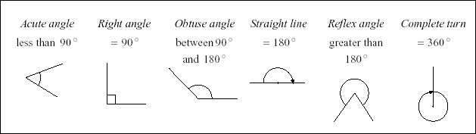

Parallel and Perpendicular

-Parallel lines or sides stay

The same distance apart.

-Perpendicular lines or sides

Meet at right angles.

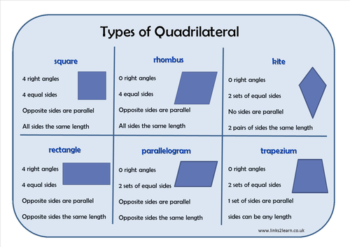

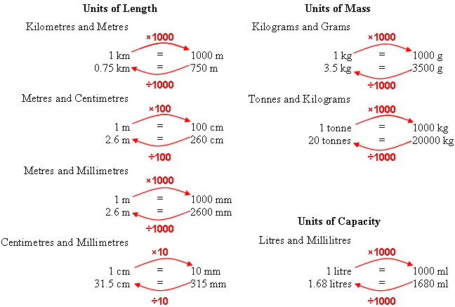

**Prime Numbers**

A number that is only divisible by itself and 1.

2, 3, 5, 7 (not 9) 11

Factors:

Factors divide into a number exactly.

Eg. The factors of 6 are: 1, 6, 2 and 3

Multiples

Think Times tables.

Multiples of 3 are: 6, 9, 12, 15 etc.

**Squared Numbers**

5² = 5 x 5 =25

**Cubed Numbers:**

5³ = 5 x 5 = 25 x 5 = 125

**Roman Numerals**

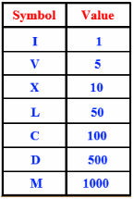

**Angle Sums**

**Quadrilaterals and about a point = 360°**

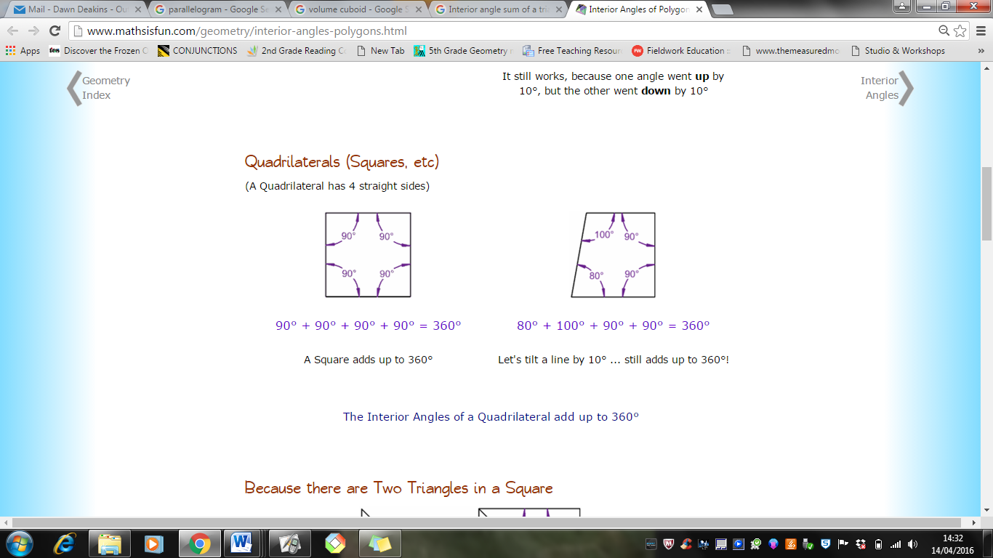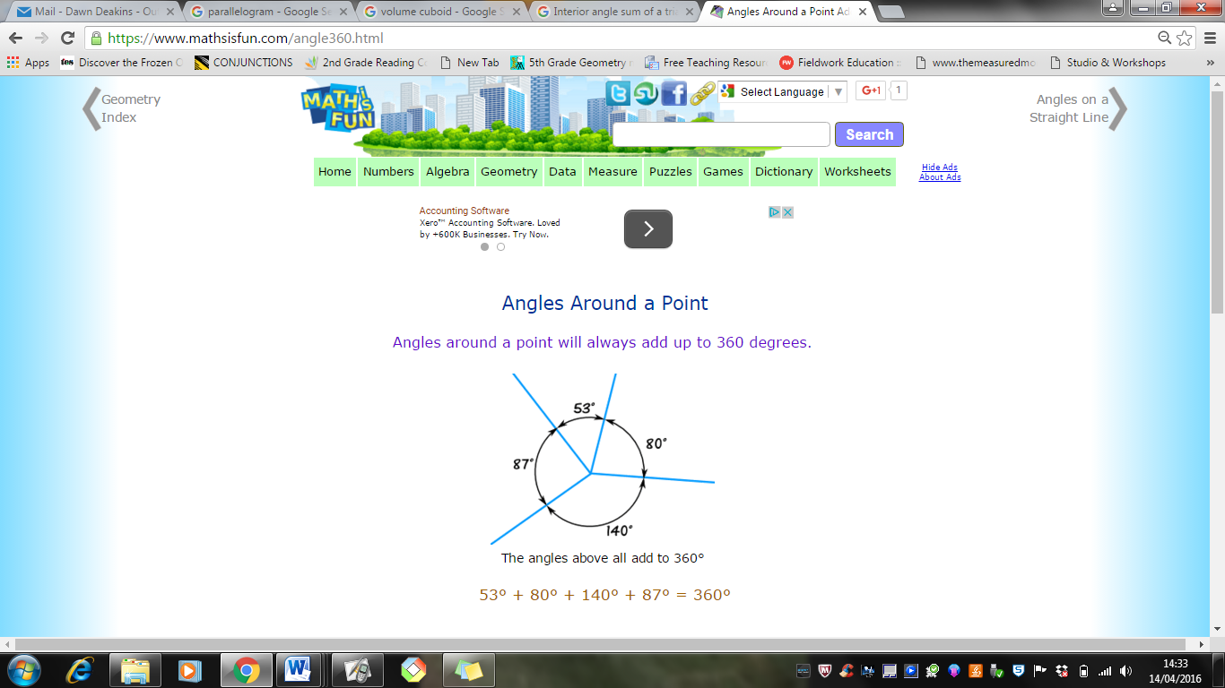

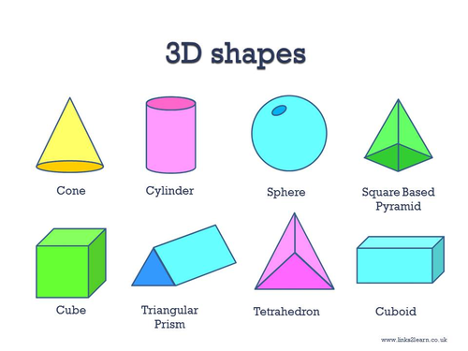

**Perimeters of Shapes**

The perimeter is the distance around a shape.

To calculate the perimeter, you add up lengths:

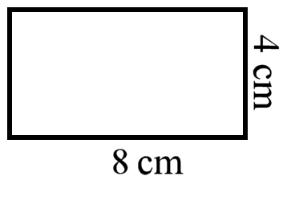

**4cm + 4cm + 8cm + 8cm = 24cm**

**Perimeter of a compound shape**

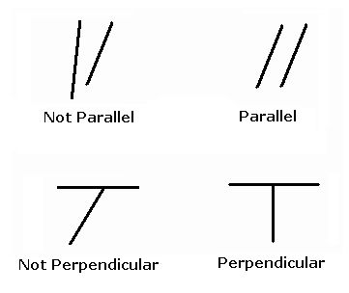

**Circles**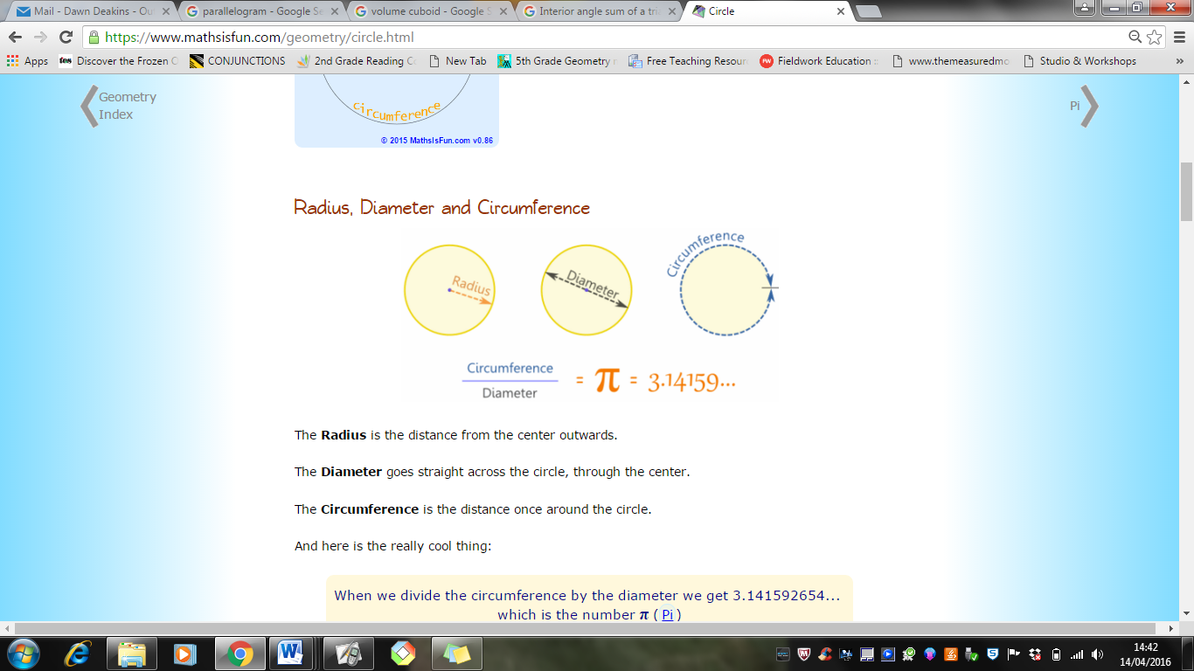

**Area of Shapes (eg. cm², mm²)**

To calculate the area of a parallelogram, rectangle or square:

**Length x Width**

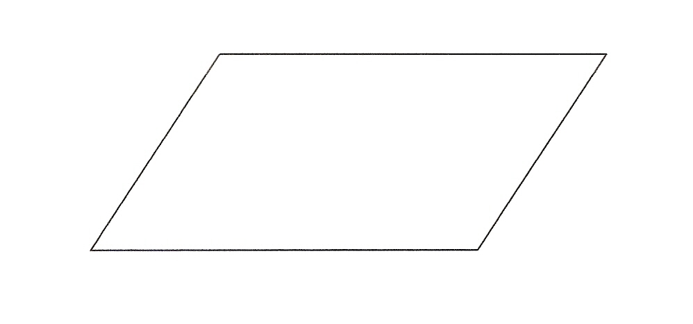

To calculate the area of triangle (eg. **cm², mm²)** :

**(Base x Height) ÷ 2**

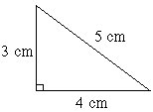

**Volume: (Remember cm³)**

Length x Width x Height

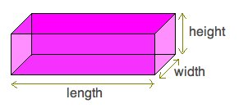

The diameter is double the radius. The circumference is the distance around the circle.

**Regular/ Irregular**

In regular shapes, all of the angles are the same and all the sides are the same length.

In irregular shapes, the angles or sides are different.

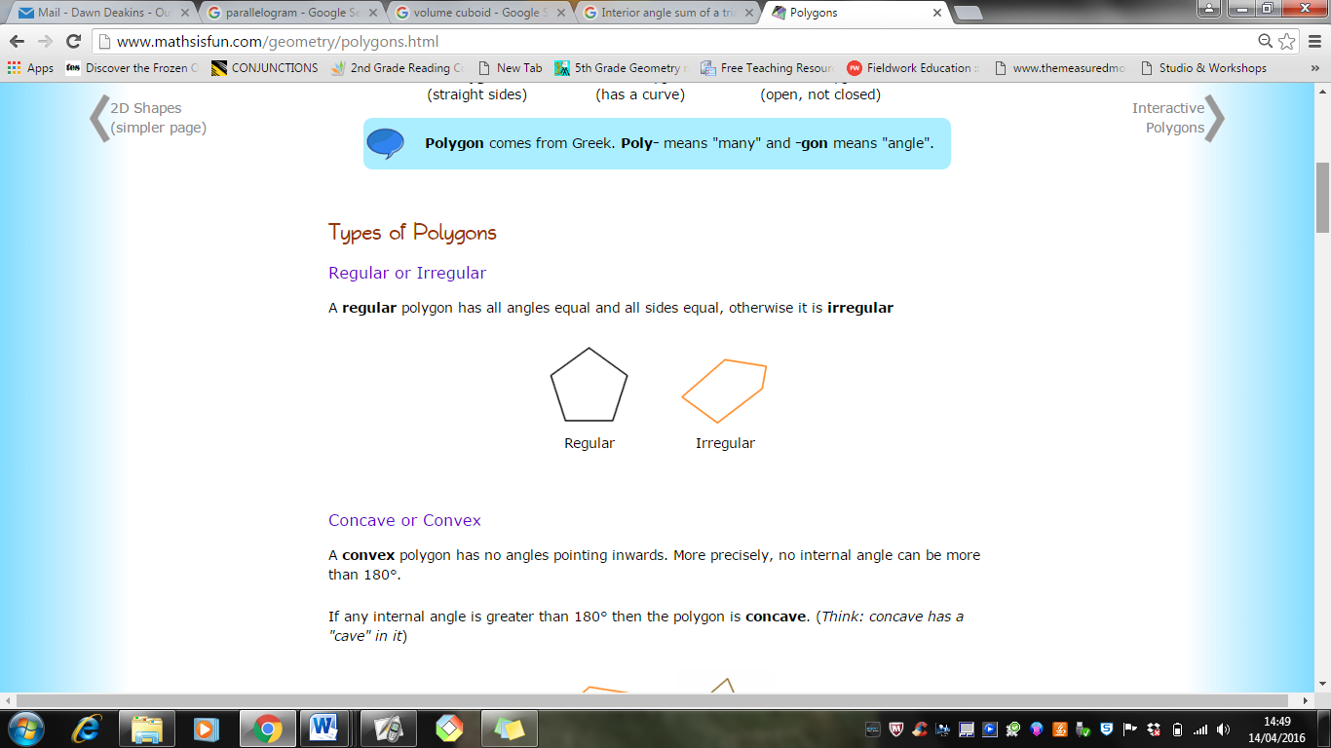

**Angle Sums**

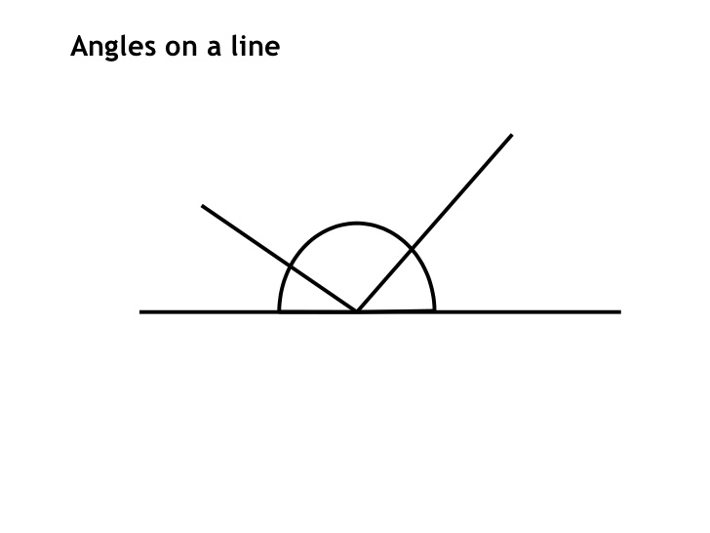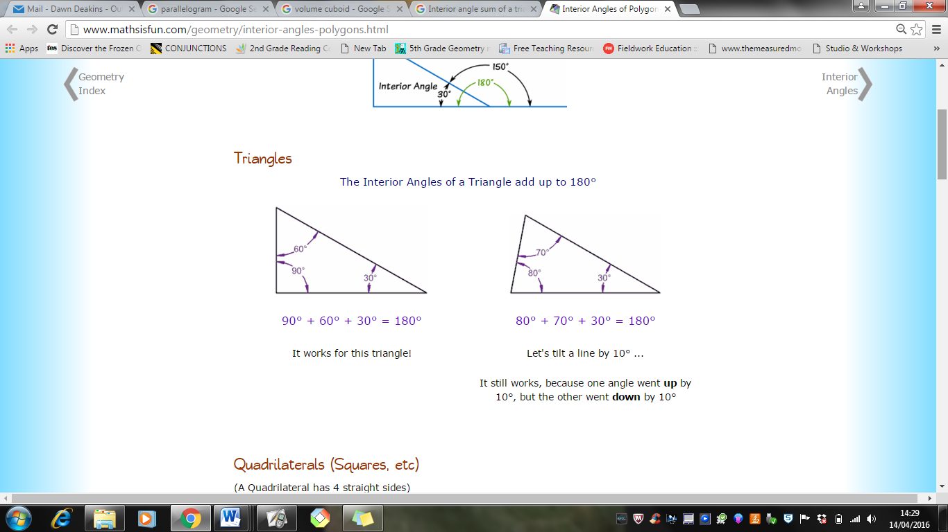

**Straight Line and a triangle = 180°**