1. This table shows when flights take off at an airport.
Flight number | Destination | Take-off time
AX40 | Paris | 13:35
BH253 | Berlin | 14:05
CG008 | Rome | 15:25
DP369 | Paris | 15:40
EZ44 | Lisbon | 16:15
FJ994 | Dublin | 17:25
How many flights take off between 3pm and 5pm?

How much later does the second flight to Paris take off than the first?

The flight to Dublin takes 50 minutes.
What time does it arrive in Dublin?
:

2. A film starts at 6:45pm.
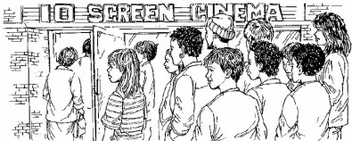
It lasts 2 hours and 35 minutes.
What time will the film finish?
…………………………..pm

3. Here is part of the timetable for Class 6 on a Monday.
Look at the timetable.
How long is it from the end of break to the start of lunch?
...............................................
1 mark
Nisha leaves the Science lesson after 25 minutes.
Then she goes to the dentist.
What time does she leave the Science lesson?

4, Jamie makes a time
line of part of his day.

What time does Jamie’s morning break start?
am

Lunch lasts for three-quarters of an hour.
What time does lunch finish?
pm

5. A clock shows this time.

How long is it from this time until 5pm?

What time was it quarter of an hour before the time on the clock?
pm

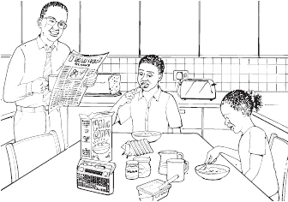
6. These are the radio programmes one morning.

7:00 Music show
7:55 Weather report
8:00 News
8:15 Travel news
8:25 Sport
8:45 Holiday programme
Josh turns the radio on at 7:25 am.
How many minutes does he have to wait for the Weather report? …………………..minutes

The Holiday programme lasts for 40 minutes.
At what time does the Holiday programme finish? ………………..am

- Here is part of a train timetable.
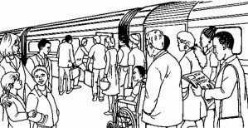
Edinburgh | – | 09:35 | – | – | 13:35 | – | –
Glasgow | 09:15 | – | 11:15 | 13:15 | – | 13:45 | 15:15
Stirling | 09:57 | – | 11:57 | 13:57 | – | 14:29 | 15:57
Perth | 10:34 | 10:51 | 12:34 | 14:34 | 14:50 | 15:15 | 16:35
Inverness | – | 13:10 | – | – | 17:05 | – | –

How long does the first train from Edinburgh take to travel to Inverness?
…………………………………………..

Ellen is at Glasgow station at 1.30pm. She wants to travel to Perth.
She catches the next train.
At what time will she arrive in Perth?
…………………………………………..

8. One of these watches is 3 minutes fast.
The other watch is 4 minutes slow.
What is the correct time?

9. These are the opening times at a swimming pool.
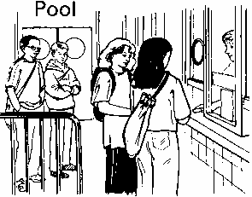

How many hours is the pool open on a Sunday?
……………………….…hours

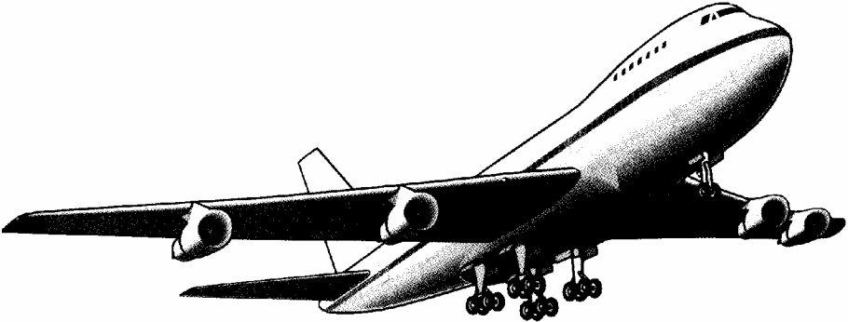
10. An aeroplane takes off on Tuesday at 22:47
It lands on Wednesday at 07:05

How long in hours and minutes is the flight?
hours minutes

11. These are the start and finish times on a DVD recorder.
START 14:45
FINISH 17:25
For how long was the DVD recording?
hours minutes

12. Jamie, Kate and Hassan run a 50m race.

Kate’s time is 13 seconds.
Jamie finishes 5 seconds before Kate.
Hassan finishes 3 seconds after Jamie.
What is Hassan’s time in seconds?
seconds

13.

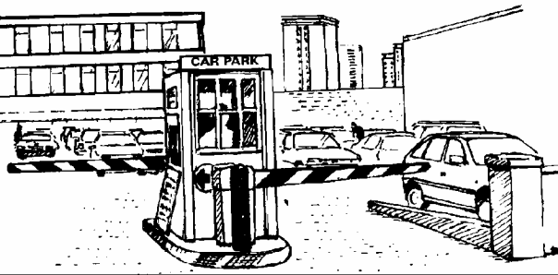
Emma parks her car at 9.30 am.
She collects the car at 1.20 pm.
How much does she pay?
……………………………………………..

Dan and Mark both use the car park.
Dan says,
‘I paid exactly twice as much as Mark but I only stayed 10 minutes longer’.
Explain how Dan could be correct.
...............................................................................................................................
...............................................................................................................................
...............................................................................................................................

14. Here are the sunrise and sunset times for some days in July.
Date | Sunrise | Sunset
7th  14th  21st  28th | 04:53  05:00  05:09  05:18 | 21:18  21:12  21:05  20:55
How many minutes earlier is the sunset on 28th July than on 7th July?
……………………………….minutes

15. Some children ran in two races on sports day.
Here are their times.
 | 100m race | 800m race
Elise | 15.9 seconds | 3 minutes 02 seconds
Jake | 19.7 seconds | 2 minutes 58 seconds
Teri | 16.8 seconds | 3 minutes 01 seconds
Neil | 17.1 seconds | 2 minutes 59 seconds
Barry | 18.4 seconds | 2 minutes 57 seconds

Who finished the 100m race in second place?
………………………………………..
In the 800m race, how many seconds did Barry finish ahead of Elise?
………………………………………..seconds

16 These are the times letters are collected from a post box.

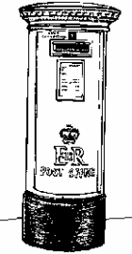
What is the latest time letters are collected on Wednesday?

Carla posts a letter at 9 am on Monday.
How long will it be before it is collected?
hours

Gareth posts a letter on Saturday at 3pm.
When is it collected from the post box?
day ............................................. time .............................................

17. Tom, Amy and Helen want to go on a boat trip.
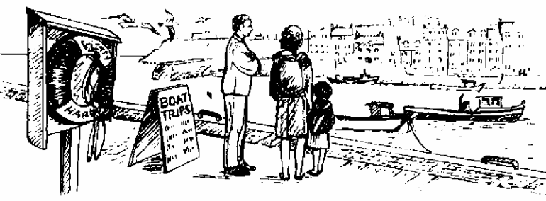
There are three boats.

Tom and Amy go on the Heron.
They leave at 2:15pm.
At what time do they return?
…………………..…….pm

Helen goes on the Kestrel and gets back at 4:15pm.
At what time did the boat leave?
………………………….pm

