1. Circle the time that is 30 minutes before midnight.
12:30 am 12:30 pm
11:30 am 11:30 pm 3 am

2. Put these times in order, starting with the shortest.
shortest

3. The time is
John has to be ready for school in half an hour.
Tick () the time when he has to be ready.

4 . Here are two clock faces.
Join each clock face to
the correct digital time.

5. The time is 10:35am.

Kate says,
‘The time is closer to 11:00am than to 10:00am’.
Explain why Kate is correct.

6. Here is a clock. How many minutes is it until this clock shows 7:30?
…………….………mins

Here is another clock. What time will the clock show in 20 minutes?
……………………

7. Two clocks show the same time.
Tick () them.
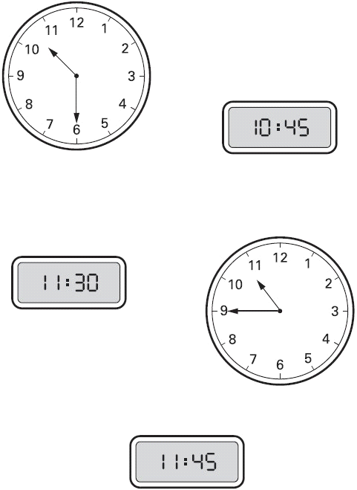

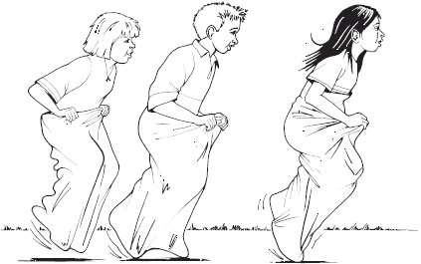
8. The Fun Day started at this time in the morning.
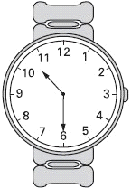
It finished at this time in the afternoon.
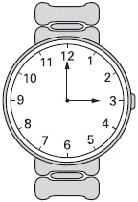
How long did the Fun Day last?
hours minutes

9. These clocks show the start and finish times of a TV programme.
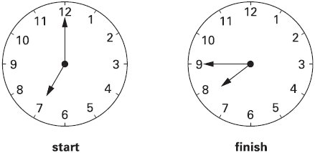
For how many minutes does the programme last?
……………………………………mins

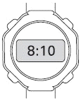
10. Jack leaves for school at this time.
It takes him 40 minutes to get to school.
Tick () the time Jack gets to school.

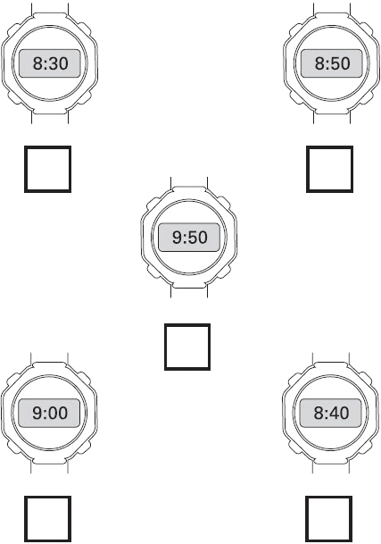

11. This was the time on Selin’s watch when she set off for a walk.

1What time did the watch show 20 minutes before this?
……………………………………………….

What time did it show an hour and a half after she set off for the walk?
…………………………………………………..

12. Here are three clock faces.
Match each clock face to the same time on a digital clock.

