1. Lin has five blocks which are all the same.
She balances them on the scale with two weights.
Calculate the weight of one block.

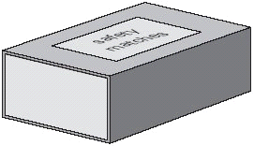
2. A box contains 220 matches and weighs 45 grams.
The empty box weighs 12 grams.
Calculate the weight of one match.

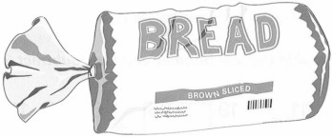
3. Every 100g of brown bread contains 6g of fibre.
A loaf of bread weighs 800g and has 20 equal slices.
How much fibre is there in one slice?

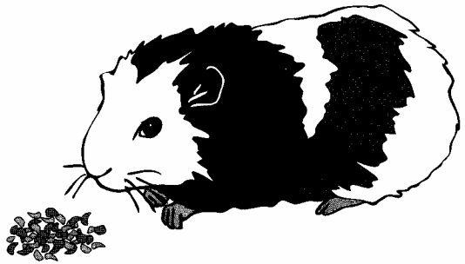
4. A packet contains 1.5 kilograms of guinea pig food.
Remi feeds her guinea pig 30 grams of food each day.

How many days does the packet of food last?

5. Amir has three parcels.
Parcels A and B together weigh the same as parcel C.
The three parcels weigh 800 grams altogether.
Parcel A weighs 250g.
How much does parcel B weigh?

