1. Here is some flour on a weighing scale.
How many grams of flour are on the scale?
grams

How much more flour must be added
to the scale to make 1.6 kg?

2. This scale shows the weight of Fred’s cat.
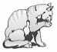
Fred’s cat
What is the weight of Fred’s cat?
kg

This scale shows the weight of Fred’s dog
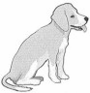
Fred’s dog
How much more does Fred’s dog weigh than his cat?
kg

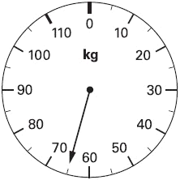
3. This scale shows how much Mrs Patel weighs.

How much does Mrs Patel weigh?
………………………………………………

4. Emily is making a cake.
She puts flour on the scales. She then adds sugar to the flour.
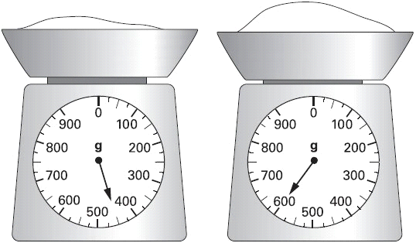
How much sugar does she add?
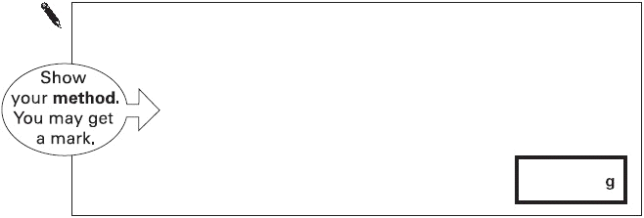

5. On this scale, the arrow (↑) shows the weight of this pineapple.
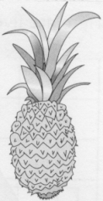
Here is a different scale.
Mark with an arrow (↑) the weight of the same pineapple.

6. Jamie is cooking pasta.
He weighs 350 grams of pasta.
Draw an arrow on the scale to show 350 grams.

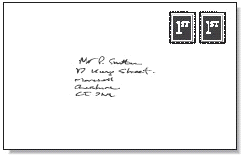
7. Here is a scale which shows the weight of a letter.

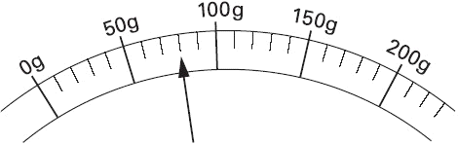
How much does the letter weigh?
grams

8. Here are some apples.
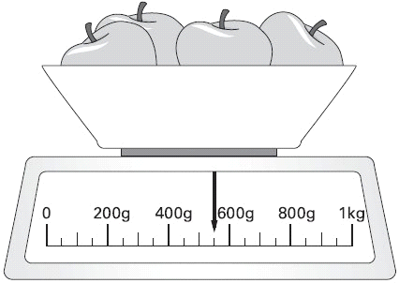
What is the total weight of these apples?
g

9. Put a ring around the lightest box.

10. What is the total mass of these apples?

