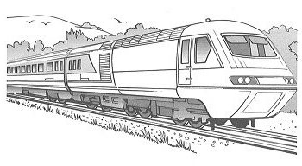
1. The diagram shows distances on a train journey from
Exeter to York.

How many kilometres is it altogether from Exeter to York?
km

2. This fence has three posts, equally spaced.

Each post is 15 centimetres wide.
The length of the fence is 153 centimetres.
Calculate the length of one gap between two posts.

3. Max jumped 2.25 metres on his second try at the long jump.
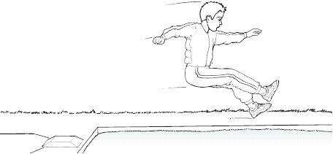
This was 75 centimetres longer than on his first try.

How far in metres did he jump on his first try?
m
1 mark

4. Here is a drawing of a model car.
What is the length of the model?
Give your answer in centimetres,
correct to one decimal place.
cm

The height of the model is 2.8 centimetres.
The height of the real car is 50 times the height of the model.
What is the height of the real car?
Give your answer in metres.

5. Kate has a piece of ribbon one metre long.

She cuts off 30 centimetres.

How many centimetres of ribbon are left?
cm

6. Here is a rectangle with six identical shaded squares inside it.
The width of the rectangle is 7.2 centimetres.
Calculate the length of the rectangle.

7. Write these lengths in order, starting with the shortest.

8. This design has one large square and
two identical small squares.
The design measures 36 centimetres by 28 centimetres.

Calculate the length of a side of the large square.

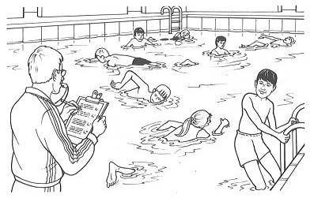
9. A rectangular swimming pool is 25 metres long and 10 metres wide.
David swims 5 lengths. Rosie swims 12 widths.
How much further does David swim than Rosie?

10. Four large circles and five small circles fit exactly inside this rectangle.
The diameter of a large circle is 17.5 centimetres.
Calculate the diameter of a small circle.

11. Martin has some bricks.
They are 12cm long, 6cm high and 6cm deep.
He builds this tower with five bricks.
How tall is the tower?
cm
1 mark
Each brick is 12cm long.
Martin makes a line of bricks 132cm long.
How many bricks does he use?
1 mark

