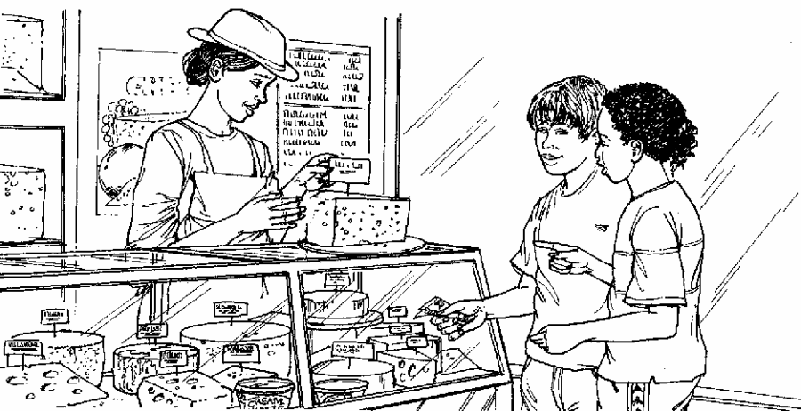
Cheddar cheese costs £7.50 for 1kg.
Marie buys 200 grams of cheddar cheese.
How much does she pay?

£

Cream cheese costs £3.60 for 1kg.
Robbie buys a pot of cream cheese for 90p.
How many grams of cream cheese does he buy?

2. Here is a recipe for raspberry ice cream.
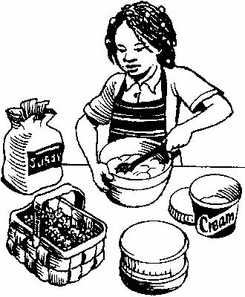
This recipe is for 8 people.
Josie makes enough raspberry ice cream for 20 people.
How much cream does she use?
litre
1

Fred makes raspberry ice cream in the same way.
He uses 3½ kg of raspberries.
How much sugar does he use?

