1. Amir and Lara buy some fruit.
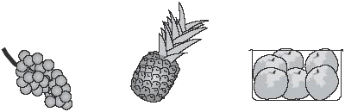

grapes pineapples peaches
£2.50 £1.40 £1.99
for 1 kilogram each for a box
Amir buys 2 pineapples and a box of peaches.
How much does he pay? £………………………………

Lara buys half a kilogram
of grapes and one pineapple.
How much change does she get from £5?

2. Here are three bags in a shop
How much does bag B cost to the nearest pound?
……………………
Jamie buys bag A and bag C.
How much change does he get from £40?

3. A torch costs £7.65
Kate buys a torch and two batteries.
She pays £8.75 altogether.
How much does one battery cost?

4. A shop sells notebooks and pens.
Hassan bought a notebook and a pen.
He paid £1.10
Kate bought a notebook and 2 pens.
She paid £1.45
Calculate the cost of a notebook.

5. A shop sells candles.
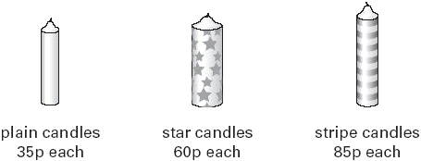

Sapna buys 4 star candles and 2 stripe candles.
How much does she pay altogether?

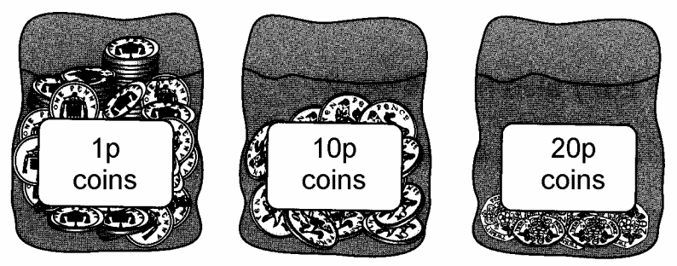
6. Each bag contains only one type of coin.
Complete this table to show how many coins
are in each bag.
One has been done for you.
Type of coin | Number of coins
1p | 160
10p
20p

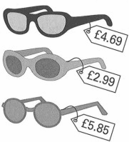
7. A shop sells three types of sunglasses.
What is the difference in price between the
most expensive and least expensive sunglasses?
£……………………………..
1 mark

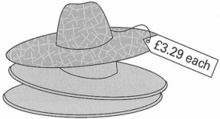
The shop also sells sun hats.
Ryan buys the £4.69 sunglasses and a sun hat.
How much change does he get from £10?

9. A shop sells scarves and hats.

Ben buys one of the scarves and the £4.50 hat.
How much change does he get from £20?

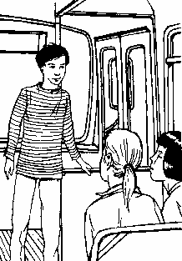
10. Asif, Vicky and Nita go to town by bus.
This is what they pay.
How much more does Nita pay than Asif?
…………………………

Vicky then takes another bus from town to visit her auntie.
She pays 90p on this bus.
How much has Vicky paid altogether for her two bus tickets?
………………………………..

11. A shop sells greetings cards.
Each card has a price code on it.
These are the codes.
Tina buys two cards.
One card has code AA on it.
The other card has code DD on it.
How much does Tina pay?
…………………………………

12. Mr Singh buys paving slabs to go around his pond.

He buys 4 rectangular
slabs and 4 square slabs.
What is the total
cost of the slabs he buys?

13. Jason bought some bags of green apples

and some bags of red apples.

He spent £4.20
6 green apples for 75p 10 red apples for 90p

How many bags of each type of apples did he buy?

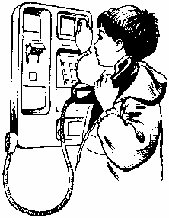
14. Lewis makes a call from a telephone box.

He has £2 in coins.
He uses these five coins to make the call.
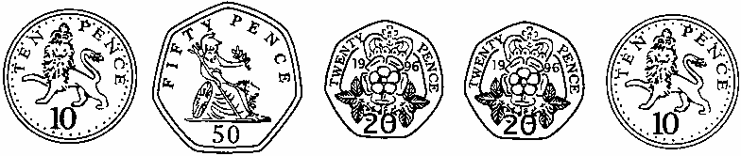
How much money has he got left from the £2?

15. This table shows the increase in bus fares.
Bus Fares
old fare | new fare
42p  52p  60p  75p  90p  £1.20 | 48p  57p  72p  85p  £1.05  £1.28 | 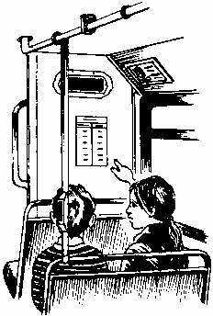
Sohan’s new bus fare is 72p.
How much has his bus fare gone up?………………………
Millie says,
‘My bus fare has gone up by 10p’.
16. How much is Millie’s new bus fare? …………………………….

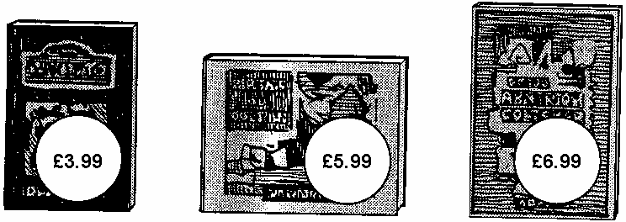
Lee bought these three books in the sale for £14.50
How much money did he save altogether compared to the full price of the books?

17. A shop sells batteries in packs of four and packs of two.
Simon and Nick want two batteries each.
They buy a pack of four and share the cost equally.
How much does each pay?

Hamid buys 1 pack of four.
How much more does Mary pay than Hamid?

18 A shop sells flowers.
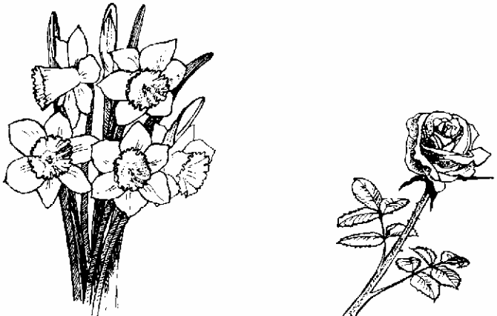
John buys 3 bunches of daffodils.
How much does he pay altogether? …………………………………..

Karpal has £4.00 to spend on roses.
How many roses can she buy for £4.00? …………………………..

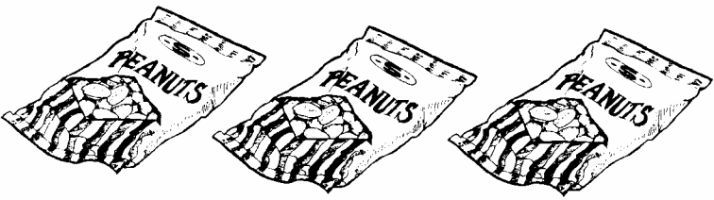
19 Parveen buys 3 small bags of peanuts.

She gives the shopkeeper £2 and gets 80p change.

What is the cost in pence of one bag of peanuts?

20. These are the prices of sandwiches, drinks and fruit.
Sandwiches | Drinks | Fruit
cheese £1.45  tuna £1.70  salad £1.20 | milk 55p  cola 45p  juice 65p | apple 15p  pear 20p  melon 25p
Shereen buys a tuna sandwich, milk and a pear.
How much does she pay?
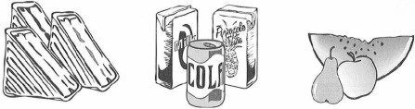
………………………………..

Mike has 80p to spend on a fruit and a drink.
What two things can he buy for exactly 80p?
.............................. and .............................

21 This table shows how many journeys a taxi driver made on five days and how much money he collected.
 | number of  journeys | money  collected
Monday | 23 | £85
Tuesday | 36 | £112
Wednesday | 18 | £69
Thursday | 31 | £124
Friday | 35 | £109
How much money did he collect on the day that he made the most journeys?
……………………………………
How much more money did he collect on Monday than on Wednesday?
……………………………………….

