1. Emily makes 250 grams of a snack mixture.
15% of the weight is raisins, 25% is banana chips
and the rest is peanuts.
How many grams of peanuts does she use?

2. Calculate 5% of £3600

£ …………………………

- Calculate 15% of 460

£ …………………………

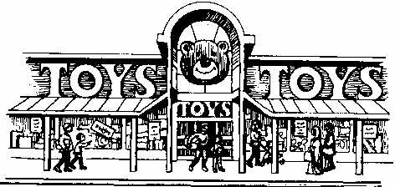
4. This chart shows the amount of money spent in a toy shop in three months.

Stepan says,
‘In November there was a 100% increase
on the money spent in October’.
Is he correct?
Circle Yes or No. Yes / No
Explain how you can tell from the chart.
...............................................................................................................................
...............................................................................................................................
...............................................................................................................................

5. Here is a grid of 20 squares. 6. Here is a pattern on a grid.
What percentage of the grid is shaded? What percentage of the grid is shaded?

………………………………% ………………..…..%

